Chemistry

Unit 3

Area of Study 3 Test:

Oxidation and reduction

This sample test paper has been prepared as part of the Pearson suite of resources for the Year 12, Unit 3, ATAR Chemistry Course prescribed by the Western Australian School Curriculum and   
Standards Authority.

Time allowed

Reading time: 5 minutes Working time: 45 minutes

Materials required

An approved non-programmable calculator.

Chemistry Data Booklet. This may be downloaded from the SCSA website.

Structure of this paper

|  |  |  |  |  |  |
| --- | --- | --- | --- | --- | --- |
| Section | Number of questions available | Number of questions to be answered | Suggested working time (minutes) | Marks available | Percentage of total test |
| Section 1: Multiple choice | 8 | 8 | 12 | 16 | 27 |
| Section 2:  Short answer | 4 | 4 | 16 | 21 | 35 |
| Section 3: Extended answer | 2 | 2 | 17 | 23 | 38 |
| Total | | | 45 | 60 | 100 |

Section 1: Multiple choice 27% (16 marks)

This section has 8 questions. Answer all questions by circling the correct option. Marks will not be deducted for incorrect answers. No marks will be given if more than one answer is completed for any question.

Suggested working time: 12 minutes

_______________________________________________________________________________

1 Which one of the following is not a redox reaction?

A Fe(s) + Cu2+(aq) → Fe2+(aq) + Cu(s)

B 2H2(g) + O2(g) → 2H2O(l)

C SO2(g) + 2H2S(g) → 2H2O(l) + 3S(s)

D Ag+(aq) + Cl−(aq) → AgCl(s)

2 The following redox reactions are spontaneous as written:

Ga(s) + In3+(aq) → Ga3+(aq) + In(s)

2In(s) + 3Ge2+(aq) → 2In3+(aq) + 3Ge(s)

Ge(s) + Pd2+(aq) → Ge2+(aq) + Pd(s)

Therefore, which of the following pairs will also react spontaneously?

I Ga(s) and Ge2+(aq)

II In(s) and Pd2+(aq)

III Pd(s) and Ga3+(aq)

A I only

B II only

C III only

D I and II only

3 Which one of the following could be a product of the reduction of SO2?

A SO32−

B H2S

C HSO4−

D Na2SO3

Questions 4 and 5 refer to the following information.

An electrochemical cell is set up under standard conditions. It is composed of a Cr3+(aq)/Cr(s) half-cell, a Cu2+(aq)/Cu(s) half-cell and a potassium nitrate salt bridge. The two half-cells are connected to a voltmeter in the external circuit.

The cell reaction is:

2Cr(s) + 3Cu2+(aq) → 2Cr3+(aq) + 3Cu(s)

4 What is the predicted cell potential, in volts, under standard conditions?

A 0.40

B 1.08

C 1.82

D 2.50

5 What is the cathode in this cell?

A Cu(s)

B Cu2+(aq)

C Cr3+(aq)

D Cr(s)

6 What do galvanic cells do, as opposed to electrolytic cells?

A produce an electric current from a spontaneous reaction

B produce an electric current from a non-spontaneous reaction

C use an external potential difference to drive a spontaneous reaction

D use an external potential difference to drive a non-spontaneous reaction

7 Consider the following unbalanced redox equation:

MnO4−(aq) + H2C2O4(aq) + H+(aq) → Mn2+(aq) + CO2(g) + H2O(l)

When the equation is correctly balanced, what are the whole number coefficients of H2C2O4(aq) and H+(aq)?

|  |  |  |
| --- | --- | --- |
|  | H2C2O4(aq) | H+(aq) |
| A | 1 | 2 |
| B | 1 | 4 |
| C | 5 | 6 |
| D | 5 | 16 |

8 In which one of the following cases will a small piece of iron sheeting rust most quickly?

A The iron sheet is coated with tin.

B The iron sheet is given a thin coat of paint.

C The iron sheet is made into the anode of an electrolytic cell.

D A block of magnesium is attached to one end of the iron sheet.

End of section 1

Section 2: Short answer 35% (21 marks)

This section has 4 questions. Answer all questions. Write your answers in the space provided.

When calculating numerical answers, show your working or reasoning clearly. Express numerical answers to three significant figures and include appropriate units where applicable.

Do not use abbreviations, such as ‘nr’ for ‘no reaction’, without first defining them.

Suggested working time: 16 minutes

___________________________________________________________________________________

Question 9 (3 marks)

What is the oxidation number of nitrogen in each of the following compounds?

|  |  |
| --- | --- |
| Compound | Oxidation number of N |
| NaNO3 |  |
| HNO2 |  |
| N2O4 |  |

Question 10 (8 marks)

a Under standard conditions, hydrogen gas is bubbled through a solution of 1.0 mol L−1 Fe3+(aq) ions.

i Write an equation for the reaction you would predict to occur. (1 mark)

____________________________________________________________________

ii However, in practice, there is no visible reaction. Provide a reason for   
this observation. (1 mark)

____________________________________________________________________

____________________________________________________________________

b i Predict what you observe if some Br2(aq) was added to a 1.0 mol L−1 solution of colourless NaI(aq). (1 mark)

____________________________________________________________________

____________________________________________________________________

ii Predict what you would observe if some Br2(aq) was added to a 1.0 mol L−1 solution of colourless NaCl(aq). (1 mark)

____________________________________________________________________

____________________________________________________________________

iii Explain your predictions in terms of the relative strength of the reducing   
agents involved. (2 marks)

____________________________________________________________________

____________________________________________________________________

____________________________________________________________________

c An electrochemical cell comprises a Ti2+(aq)/Ti(s) half-cell connected to a Cu2+(aq)/Cu(s) half-cell under standard conditions. Reduction occurs at the Cu electrode and the cell is predicted to produce a voltage of 1.97 V. Deduce the standard reduction potential of:

Ti2+(aq) + 2e− ⇌ Ti(s) (2 marks)

__________________________________________________________________________

__________________________________________________________________________

__________________________________________________________________________

Question 11 (6 marks)

The rechargeable nickel–cadmium (Ni-Cad) cell can be used to power small appliances.

The electrolyte is alkaline and the overall cell reaction when this cell is providing electricity is:

Cd(s) + 2NiO(OH)(s) + 2H2O(l) → Cd(OH)2(s) + 2Ni(OH)2(s)

a Consider what happens when this cell is providing electricity.

i One of the electrode reactions is:

Cd(s) + 2OH−(aq) → Cd(OH)2(s) + 2e−

Does this reaction occur at the anode or cathode of the cell? (1 mark)

____________________________________________________________________

ii Deduce the other electrode reaction. (1 mark)

____________________________________________________________________

____________________________________________________________________

iii What is the oxidation number of nickel in NiO(OH)(s) and in Ni(OH)2? (2 marks)

____________________________________________________________________

b Consider what happens when this cell is being recharged.

i Write the reaction at the cathode. (1 mark)

____________________________________________________________________

ii What feature must a secondary cell have in order to allow it to be recharged? (1 mark)

____________________________________________________________________

Question 12 (4 marks)

A fuel cell, based on the reaction between methanol (CH3OH(g)) and oxygen (O2(g)), has been developed for possible use in small electronic devices. The cell uses an acidic electrolyte and one of the products of the cell reaction is carbon dioxide (CO2(g)).

a Give the half-equation for the anode reaction. (1 mark)

___________________________________________________________________________

___________________________________________________________________________

b Give the half-equation for the cathode reaction. (1 mark)

___________________________________________________________________________

___________________________________________________________________________

c Write the overall cell equation. (1 mark)

___________________________________________________________________________

___________________________________________________________________________

d Identify one fundamental difference between a fuel cell and a galvanic cell such as the one that is used to power a torch. (1 mark)

___________________________________________________________________________

___________________________________________________________________________

End of section 2

Section 3: Extended answer 38% (23 marks)

This section has 2 questions. Answer both questions. Write your answers in the space provided.

When calculating numerical answers, show your working or reasoning clearly. Express numerical answers to three significant figures and include appropriate units where applicable.

Do not use abbreviations, such as ‘nr’ for ‘no reaction’, without first defining them.

Suggested working time: 17 minutes

____________________________________________________________________________________

Question 13 (13 marks)

A galvanic cell, under standard conditions, is set up as shown in the following diagram.

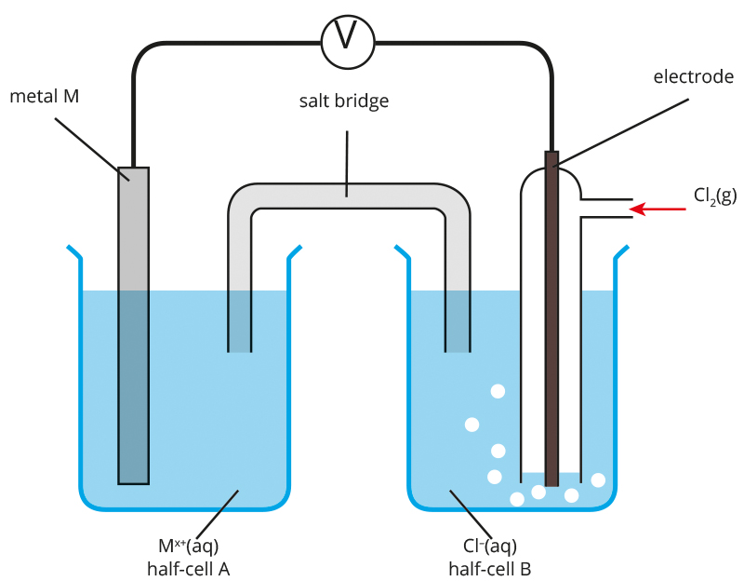

a Identify a material that would be suitable for the electrode in the solution of chloride ions in half-cell B. (1 mark)

____________________________________________________________________

b The predicted potential difference that can be generated by this cell is 1.49 V. Deduce the identity of metal M and metal ions M*x*+. (3 marks)

____________________________________________________________________

____________________________________________________________________

____________________________________________________________________

____________________________________________________________________

c State whether the electrode made of metal M in half-cell A is the anode or cathode in   
this cell. (1 mark)

____________________________________________________________________

d On the diagram itself, show the direction of electron flow in the external circuit. (1 mark)

e i Give the formula of an ionic compound that can be used in the salt bridge. (1 mark)

____________________________________________________________________

ii On the diagram itself, show the direction in which the cations and anions of your chosen compound move in the salt bridge. (1 mark)

f For this galvanic cell, write an equation for the:

i oxidation half-reaction (1 mark)

____________________________________________________________________

ii reduction half-reaction (1 mark)

____________________________________________________________________

iii overall cell reaction (1 mark)

____________________________________________________________________

g Explain how you can use this galvanic cell to determine whether an unknown metal is more or less reactive than metal M. (2 marks)

__________________________________________________________________________

__________________________________________________________________________

### Question 14 (10 marks)

Electrolytic cells are used industrially for a number of applications. This diagram shows a cell that can be used to electroplate a thin layer of nickel on an iron spoon.

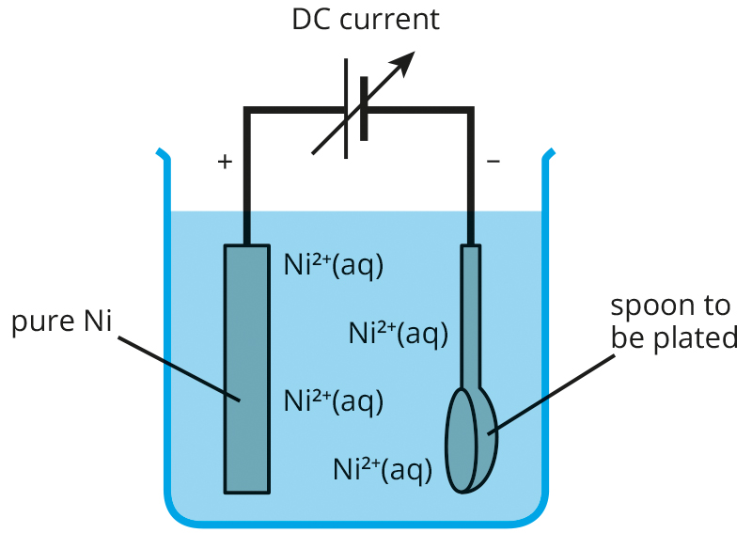

**a i** Write the half-equation for the reaction that causes the spoon to be   
nickel plated. (1 mark)

____________________________________________________________________

**ii** Does the spoon form the anode or cathode of the cell? Explain your choice. (2 marks)

____________________________________________________________________

____________________________________________________________________

**b i** Write the half-equation for the reaction at the Ni electrode. (1 mark)

____________________________________________________________________

**ii** What would you observe at the Ni electrode after some time? (1 mark)

____________________________________________________________________

____________________________________________________________________

c Ni2+(aq) ions are green. What would you observe about the intensity of the green colour of the plating bath as the electroplating proceeds? (1 mark)

___________________________________________________________________________

___________________________________________________________________________

d Calculate the amount, in mol, of electrons that would be needed to deposit 0.935 g of nickel on the spoon. (2 marks)

___________________________________________________________________________

___________________________________________________________________________

___________________________________________________________________________

e Explain why this method is also suitable for electroplating silver onto metal objects but is not suitable for electroplating magnesium onto metal objects. (2 marks)

___________________________________________________________________________

___________________________________________________________________________

___________________________________________________________________________

## End of questions